

ICS 3207/MIT 3105

SOFTWARE/IT PROJECT MANAGEMENT
BY

Dr. Kennedy Ogada
CHAPTER 1

What is a project?
Any planned undertaking that takes or consumes resources, has a starting and ending time, results in a finished product.

Two essential features of a project that must be present in every project:
- All projects must be planned out in advance, if they are to be successful.
- The execution of the project must be controlled to ensure that the desired results are achieve.

Activity or Task
This is the smallest unit of work effort within the project and consumes both time and resources which are under the control of the project management.

Project Management
The use of techniques and skills in planning and controlling tasks and resources needed for the project from both inside and outside the organisation to achieve results.
- The purpose of project management is to achieve successful completion with the resources available.

Characteristics of a successfully completed project
- Completed on time.
- Completed within its cost budget.
- Performs to a technical or performance criteria

Purpose of Project Management
- To achieve successful project completion with the resources available.
- The effectiveness of project management is critical in ensuring the success of any project.
- Planning, control and implementation are some of the areas of responsibility for the project manager.

Successful Project
To be successful, a project must have the following characteristics:

- A clearly defined business objective.
- A partnership approach.
- A project sponsor.
- Support of senior management.
- Regular progress reporting.
- Consistent progress reporting.
- A proven project management methodology.
- Benefits realization.

Responsibilities of a project Manager
Planning all aspects of the project.
- Controlling the organisation of manpower needed by the project.
- Controlling the basic technical definition of the project, ensuring that technical versus cost trade-off is determined, and the specific areas where optimization is necessary.
- Leading the people and organizations assigned to the project at any given point in time.
- Monitoring performance, costs, and efficiency.
- Completing the project on schedule and within costs, these being the overall standards by which performance of the project manager is evaluated.

Reasons for project failures
- Project goals are not clearly defined.
- Constraints arising from the different objectives of short-time scale, resource availability, quality factors and human factors.

Problems with project Goals
- The project sponsor or client has inadequate idea of what the project is about at the start.
- Failure of communication between the client and the project manager, and due to lack of technical knowledge on the part of the clients and use of jargons by the project manager.
- Specifications may be subject to constant change due to problems with individual clients, decision making processes, at the client end, or environmental changes.
- The project goals are unrealistic and unachievable and this may only be realised once the project is started.
- Project may be highly complex and may have a number of objectives that contradict each other.

Properly defined and Achievable Goals
- The client specification is clear and understandable.
- This is done through establishing the objectives of the project.
- This can be validated by finding answers to the following questions:
- What is it that the organisation is setting out to achieve?
- Will the suggested project fulfil these objectives?
Questions?
  - Has all the alternatives been considered and is the choice option the best one available?
  - Has the full effects of the project, both inside and outside the organisation been considered.

SMART Goals
- Specific: Goals are clear to everyone with the basic knowledge of the project.
- Measurable: Goals must have an indicator to show that the goal is achievable.
- Agreed-upon: there must be agreement between users and the project team on the goals.
- Realistic: The goals can be accomplished with resources, knowledge and time available.
- Time-framed: The time needed to accomplish the goal should be determined.

Constraints on the completion of the Project
- Time: There is likely to be some relationship between the time taken for a project and its cost. Trade-off between the 2 constraint factors (time & Cost) may then be necessary.
- Resource Availability: The overall resource available may in theory be insufficient to complete the project. However, there may be difficulties arising from the way in which the project has been scheduled.
- Quality Factors: The project should deliver the goals or products of the right qualities.

Techniques to overcome constraints
- Budgeting
- Project planning
- Project control

Defining a Project
Effective project management involves careful operations and clear thought out processes. Before any tools or techniques can be used in the process of project management, the project must be clearly defined.
The 3 key components that need to be considered and understood are:
- Specific outcomes of the project: e.g. goals, results, deliverables and products.
- Deadlines.
- Established budgets for finances, personnel and equipment’s.
Project life Cycle
Conceive
Define
Start
Perform
Close

Conceive Phase
Is concerned with the idea and the potential for the project.
It is critical because the decision to pursue a project or not is taken according to the measures of the project.
Key questions asked are:
- Should the project be done?
- Can the project be done?

Define Phase
The project plan is the key to defining the project and must include the following:
Reasons for the project.
- Details of results of products.
- Listing of all work or tasks to be performed.
- Detailed schedule of work and tasks.
- Budgets for work
- Assumptions made.
- Contingency plans.

Start Phase
The key tasks in this phase are:
- Assigning people to roles.
- Giving and explaining tasks to all members.
- Defining how the team will perform tasks.
- Setting-up necessary tracking systems.
- Announce project to organisation.

Perform Phase
Tasks done are:
- Comparison of planned and actual project performance is made.
- Problem solving: proactive problem solving can help in avoiding major deviations from planned project work and keeping the deviations within allowed contingency.

Close Phase
This phase involves stopping tasks and accepting or approving results and deliverables.

Common problems with software projects
- Lack of quality standards.
- Lack of measurable milestones.
- Making progress visible is difficult.
- Poor communication.
- Poor documentation.
- Frequent changes of requirements.
- Over budget and late delivery of software.

Project Management and Information Technology Context

Acknowledgments
Notes adapted from Information Technology Project Management (7th Edition) By Kathy
Schwalbe

Learning Outcomes
By the end of this chapter, the learner should be able to:
- Understand the growing need for better project management, especially for information technology (IT) projects
- Explain what a project is, provide examples of IT projects, list various attributes of projects, and describe the triple constraint of project management
- Describe project management and discuss key elements of the project management framework.
- Discuss the relationship between project, program, and portfolio management and the contributions each makes to enterprise success
- Understand the role of project managers by describing what they do, what skills they need, and career opportunities for IT project managers – Describe the project management profession.
Introduction
- New technologies have become a significant factor in many businesses.
- Computer hardware, software, networks, and the use of interdisciplinary and global work teams have radically changed the work environment.
- IT projects involve using hardware, software, and networks to create a product, service, or result.
- Today’s companies, governments, and non-profit organizations are recognizing that to be successful, they need to use modern project management techniques, especially for IT projects.
- Individuals are realizing that to remain competitive in the workplace, they must develop skills to become good project team members and project managers.
- They also realize that many of the concepts of project management will help them in their everyday lives as they work with people and technology on a day-to-day basis.

Advantages of Using Project Management Techniques
- Better control of financial, physical, and human resources
- Improved customer relations
- Shorter development times
- Lower costs and improved productivity
- Higher quality and increased reliability
- Higher profit margins
- Better internal coordination
- Positive impact on meeting strategic goals
- Higher worker morale

What is a Project?
A project is “a temporary endeavour undertaken to create a unique product, service, or result.”
Operations, on the other hand, is work done in organizations to sustain the business.
Projects are different from operations in that they end when their objectives have been reached or the project has been terminated.

Examples of IT Projects
- A team of students creates a smartphone application and sells it online.
- A company develops a driverless car.
- A small software development team adds a new feature to an internal software application for the finance department.
- A college upgrades its technology infrastructure to provide wireless Internet access across the whole campus.
- A company develops a new system to increase sales force productivity and customer relationship management that will work on various laptops, smartphones, and tablets.
- A television network implements a system to allow viewers to vote for contestants and provide other feedback on programs via social media sites.
- A government group develops a system to track child immunizations.
- A large group of volunteers from organizations throughout the world develops standards for environmentally friendly or green IT.
- A global bank acquires a smaller financial institution and needs to reconcile systems and procedures into a common entity.
- Government regulations require new reporting of commercial business data for a manufacturing company.
- A multinational firm decides to consolidate its information systems into an integrated enterprise resource management approach

Project Attributes
- A project has a unique purpose.
- A project is temporary.
- A project is developed using progressive elaboration.
- A project requires resources, often from various areas.
- A project should have a primary customer or sponsor.
- A project involves uncertainty.

Project Constraints
- Every project is constrained in different ways, often by its scope, time, and cost goals.
- These limitations are sometimes referred to in project management as the triple constraint.
- To create a successful project, a project manager must consider scope, time, and cost and balance these three often-competing goals
- Managing the triple constraint involves making trade-offs between scope, time, and cost goals for a project.
  - E.g. a project manager might need to increase the budget for a project to meet scope and time goals.
- Alternatively, project manager might have to reduce the scope of a project to meet time and cost goals.
- Experienced project managers know that you must decide which aspect of the triple constraint is most important.
- If time is most important, you must often change the initial scope and cost goals to meet the schedule.
- If scope goals are most important, you may need to adjust time and cost goals.

What Is Project Management?
- Project management is “the application of knowledge, skills, tools, and techniques to project activities to meet project requirements.”
- Project managers must strive not only to meet specific scope, time, cost, and quality goals of projects, they must also facilitate the entire process to meet the needs and expectations of people involved in project activities or affected by them.

Project Stakeholders
- Stakeholders are the people involved in or affected by project activities, and include:
  - Project sponsor,
  - Project team, – Support staff,
  - Customers, users, suppliers, and even opponents of the project.
- These stakeholders often have very different needs and expectations.

Project Management Knowledge Areas
Project management knowledge areas describe the key competencies that project managers must develop:
- Project scope management involves defining and managing all the work required to complete the project successfully.
- Project time management includes estimating how long it will take to complete the work, developing an acceptable project schedule, and ensuring timely completion of the project
- Project cost management consists of preparing and managing the budget for the project.
- Project quality management ensures that the project will satisfy the stated or implied needs for which it was undertaken.
- Project human resource management is concerned with making effective use of the people involved with the project.
- Project communications management involves generating, collecting, disseminating, and storing project information.
- Project risk management includes identifying, analyzing, and responding to risks related to the project.
- Project procurement management involves acquiring or procuring goods and services for a project from outside the performing organization.
- Project stakeholder management includes identifying and analyzing stakeholder needs while managing and controlling their engagement throughout the life of the project.
- Project integration management is an overarching function that affects and is affected by all of the other knowledge areas.
Project Management Tools and Techniques
- Thomas Carlyle, a famous historian and author, stated, “Man is a tool-using animal.
- Without tools he is nothing, with tools he is all.”
- As the world continues to become more complex, it is even more important for people to develop and use tools, especially for managing important projects.
- Project management tools and techniques assist project managers and their teams in carrying out work in all 10 knowledge areas.
  - E.g. some popular time-management tools and techniques include Gantt charts, project network diagrams, and critical path analysis.

Knowledge  Area/Category | Tools and Techniques
Scope management | Scope statements, work breakdown structures, statements of work, requirements analyses, scope management plans, scope verification techniques, scope change controls
Time management | Gantt charts, project network diagrams, critical path analysis, crashing, fast tracking, schedule performance measurements
Integration  management | Project selection methods, project management methodologies, stakeholder analyses, work requests, project charters, project management plans, project management software, change requests, change control boards, project review meetings, lessonslearned reports
Cost  management | Project budgets, net present value, return on investment, payback analysis, earned value management, project portfolio management, cost estimates, cost management plans, cost baselines
Quality  management | Quality metrics, checklists, quality control charts, Pareto diagrams, fishbone diagrams, maturity models, statistical methods, test plans
Risk management | Risk management plans, risk registers, probability/impact matrices, risk rankings
Procurement management matrices | Make-or-buy analyses, contracts, requests for proposals or quotes, source selections, supplier evaluation
Communications management |  | plans, kick-off meetings, conflict  management, communications media selection, status and progress reports, virtual communications, templates, project Web sites
Human resource management | Motivation techniques, empathic listening, responsibility assignment matrices, project organizational charts, resource histograms, team building exercises Communications management

Project Management
Despite its advantages, project management is not a silver bullet that guarantees success on all projects.
Project management is a very broad, often complex discipline.
What works on one project may not work on another, so it is essential for project managers to continue to develop their knowledge and skills in managing projects.
It is also important to learn from the mistakes and successes of others.
Project Success
- The project met scope, time, and cost goals.
- The project satisfied the customer/sponsor.
- The results of the project met its main objective, such as making or saving a certain amount of money, providing a good return on investment, or simply making the sponsors happy.
What helps projects succeed?

- User involvement
- Executive support
- Clear business objectives
- Emotional maturity
- Optimizing scope
- Agile process
- Project management expertise
- Skilled resources
- Execution
- Tools and infrastructure

- Project managers play an important role in making projects, and therefore organizations, successful.
- Project managers work with the project sponsors, the project team, and other stakeholders to meet project goals.
- They also work with sponsors to define success for particular projects.
- Good project managers do not assume that their definition of success is the same as the sponsors’.
- They take the time to understand their sponsors’ expectations and then track project performance based on important success criteria.
Program and Project Portfolio Management
- A program is “a group of related projects managed in a coordinated way to obtain benefits and control not available from managing them individually.
- It is often more economical to group projects together to help streamline management, staffing, purchasing, and other work.
Examples of common Programs in the IT field
- Infrastructure
An IT department often has a program for IT infrastructure projects.
This program could encompass several projects, such as providing more wireless Internet access, upgrading hardware and software, and developing and maintaining corporate standards for IT.

Applications development
This program could include several projects, such as updating an enterprise resource planning (ERP) system, purchasing a new off the-shelf billing system, or developing a new capability for a customer relationship management system.
- User support
In addition to the many operational tasks related to user support, many IT departments have several projects to support users.
For example, a project might provide a better e-mail system or develop technical training for users.
What do Program Managers do?
- A program manager provides leadership and direction for the project managers heading the projects within a program.
- Program managers also coordinate the efforts of project teams, functional groups, suppliers, and operations staff supporting the projects to ensure that products and processes are implemented to maximize benefits.
- Program managers are responsible for more than the delivery of project results; they are change agents responsible for the success of products and processes developed by those projects.
Project Portfolio Management
- In many organizations, project managers also support an emerging business strategy of project portfolio management (also called portfolio management), in which organizations group and manage projects and programs as a portfolio of investments that contribute to the entire enterprise’s success.
- Portfolio managers’ help their organizations make wise investment decisions by helping to select and analyse projects from a strategic perspective.
- Portfolio managers may or may not have previous experience as project or program managers.
- It is most important that they have strong financial and analytical skills and understand how projects and programs can contribute to meeting strategic goals

Project management compared to project portfolio management
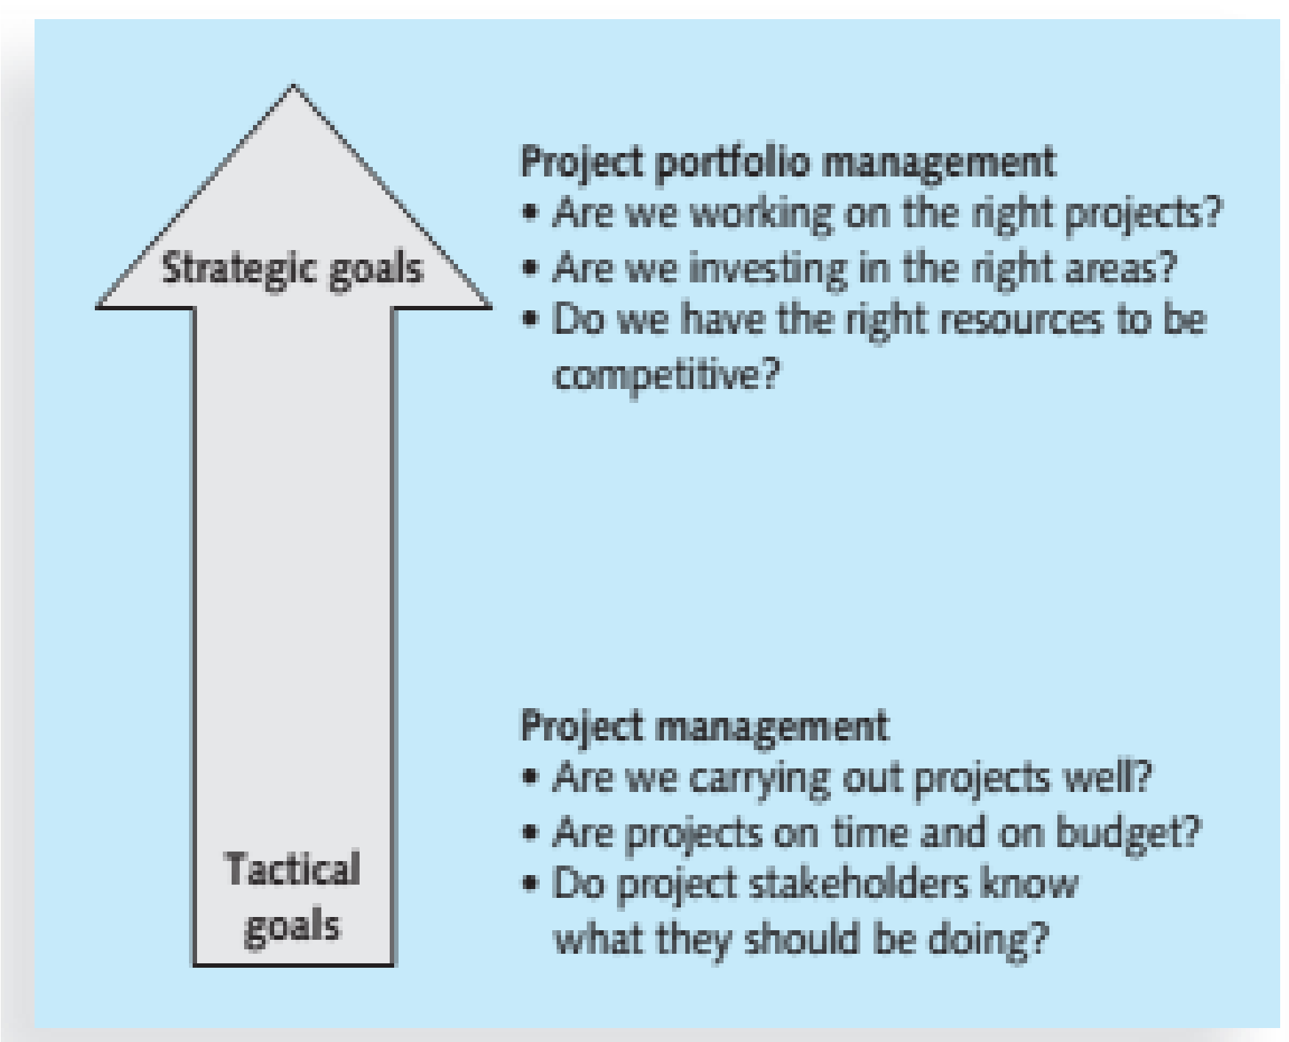

Three basic IT project Portfolio categories
- Venture
Projects in this category help transform the business.
For example, a large retail chain might have an IT project to provide kiosks in stores and similar functionality on the Internet where customers and suppliers could quickly provide feedback on products or services.
This project could help transform the business by developing closer partnerships with customers and suppliers.
- Growth
Projects in this category would help the company grow in terms of revenues.
For example, a company might have an IT project to provide information on its corporate Web site in a new language, such as Chinese or Japanese.
This capability could help the company grow its business in those countries
- Core
Projects in this category must be accomplished to run the business.
For example, an IT project to provide computers for new employees would fall under this category.
The Role of Project Manager
- A project manager can have many different job descriptions, which can vary tremendously based on the organization and the project.
- The job description for a project manager can vary by industry and by organization, but most project managers perform similar tasks regardless of these differences.
The Role of Project Manager
Responsibilities include business analysis, requirements gathering, project planning, budget estimating, development, testing, and implementation. Responsible for working with various resource providers to ensure development is completed in a timely, high-quality, and cost-effective manner.
Suggested Skills for Project Managers
- The Project Management Body of Knowledge
- Application area knowledge, standards, and regulations
- Project environment knowledge
- General management knowledge and skills
- Soft skills or human relations skills
Project environment knowledge
- The project environment differs from organization to organization and project to project, but some skills will help in almost all project environments.
- These skills include understanding change and understanding how organizations work within their social, political, and physical environments.
- Project managers must be comfortable leading and handling change, because most projects introduce changes in organizations and involve changes within the projects themselves.
- Project managers need to understand the organization in which they work and how that organization develops products and provides services
General management knowledge and skills
- They should understand important topics related to financial management, accounting, procurement, sales, marketing, contracts, manufacturing, distribution, logistics, the supply chain, strategic planning, tactical planning, operations management, organizational structures and behaviour, personnel administration, compensation, benefits, career paths, and health and safety practices.
Soft skills or human relations skills
- Achieving high performance on projects requires soft skills, otherwise called human relations skills. Some of these soft skills include effective communication, influencing the organization to get things done, leadership, motivation, negotiation, conflict management, and problem solving
Ethics in Project Management
- Ethics, loosely defined, is a set of principles that guides decision making based on personal values of what is considered right and wrong.
- Making ethical decisions is an important part of project managers’ personal and professional lives because it generates trust and respect with other people.
Ethics in Project Management
Project managers often face ethical dilemmas.
- For example, several projects might involve different payment methods If project managers can make more money by doing their jobs poorly, should they? No! Should a project manager who is personally opposed to the development of nuclear weapons work on a project that helps produce them? Yes! Ethics guide us in making these types of decisions
A Systems View of Project Management
- Even though projects are temporary and intended to provide a unique product or service, you cannot run projects in isolation.
- If project managers lead projects in isolation, it is unlikely that they will ever truly serve the needs of the organization.
- Therefore, projects must operate in a broad organizational environment, and project managers need to consider projects within the greater organizational context.
- To handle complex situations effectively, project managers need to take a holistic view of a project and understand how it relates to the larger organization.
- Systems thinking describes this holistic view of carrying out projects within the context of the organization.
What Is a Systems Approach?
- The term systems approach emerged in the 1950s to describe a holistic and analytical approach to solving complex problems that includes using a systems philosophy, systems analysis, and systems management.
- A systems philosophy is an overall model for thinking about things as systems.
- Systems are sets of interacting components that work within an environment to fulfil some purpose.
- Systems analysis is a problem-solving approach that requires defining the scope of the system, dividing it into components, and then identifying and evaluating its problems, opportunities, constraints, and needs.
- Once this is completed, the systems analyst then examines alternative solutions for improving the current situation; identifies an optimum, or at least satisfactory, solution or action plan; and examines that plan against the entire system.
- Systems management addresses the business, technological, and organizational issues associated with creating, maintaining, and modifying a system.
- Using a systems approach is critical to successful project management.
The Three-Sphere Model for Systems Management
The simple idea of addressing the three spheres of systems management:
- business,
- organization, and
- Technology can have a huge impact on selecting and managing projects successfully.
Life Cycle
- Because projects operate as part of a system and involve uncertainty, it is good practice to divide projects into several phases.
- A project life cycle is a collection of project phases.
- Some organizations specify a set of life cycles for use in all of their projects, while others follow common industry practices based on the types of projects involved.
Project Phases and the Project Life Cycle
- In general, project life cycles define what work will be performed in each phase, what deliverables will be produced and when, who is involved in each phase, and how management will control and approve work produced in each phase.
Life Cycle
A deliverable is a product or service, such as a technical report, a training session, a piece of hardware, or a segment of software code, produced or provided as part of a project
Project Phases and the Project
- Project phases vary by project or industry, but general phases in traditional project management are often called the concept, development, implementation, and close-out phases.
Project Phases and the Project Life Cycle
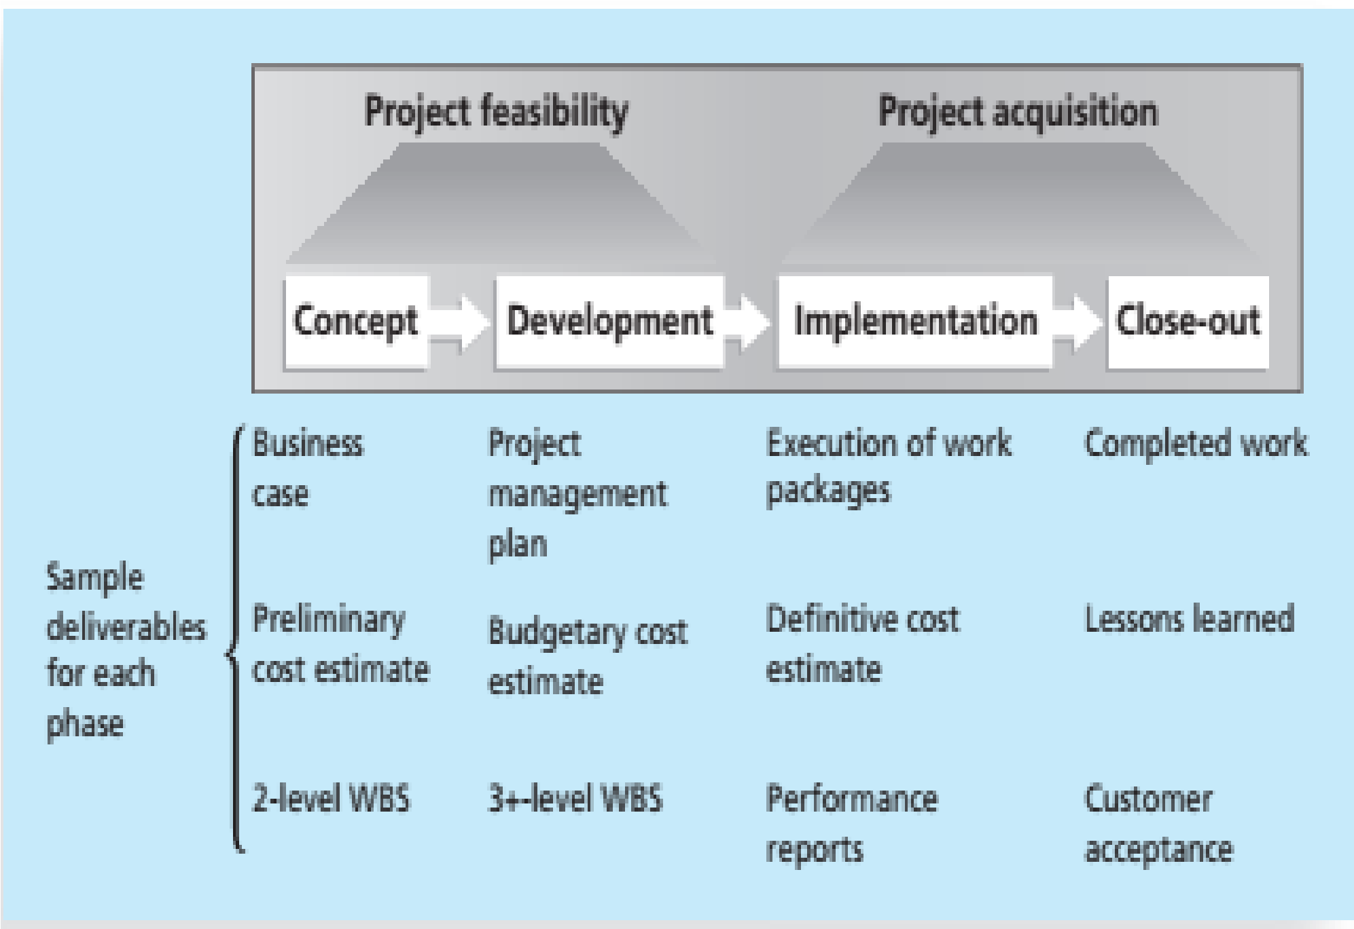

Life Cycle: Concept Phase
- In the concept phase of a project, managers usually develop some type of business case, which describes the need for the project and basic underlying concepts.
- A preliminary or rough cost estimate is developed in this first phase, and an overview of the required work is created
Life Cycle: Concept Phase
- A work breakdown structure (WBS) outlines project work by decomposing the work activities into different levels of tasks.
- The WBS is a deliverable oriented document that defines the total scope of the project.
- At the end of the concept phase, a committee would be able to deliver a report and presentation on its findings.
- The report and presentation would be examples of deliverables.
Life Cycle: Development Phase
- In the development phase, the project team creates more detailed project management plans, a more accurate cost estimate, and a more thorough WBS.
Life Cycle: Implementation Phase
- In this phase, the project team creates a definitive or very accurate cost estimate, delivers the required work, and provides performance reports to stakeholders.
Life Cycle: Implementation Phase
- During the implementation phase, the project team would need to obtain the required hardware and software, install the necessary network equipment, deliver the hardware required, create a process for collecting fees, and provide training to clients.
- The project team usually spends the bulk of its efforts and money during the implementation phase of projects.
Life Cycle: Close Out Phase
- In this phase, all of the work is completed, and customers should accept the entire project.
- The project team should document its experiences on the project in a lessons learned report.

Product Life Cycles
- Developing a product often involves many projects.
- Software development projects are one subset of IT projects.
- Many IT projects involve researching, analysing, and then purchasing and installing new hardware and software with little or no actual software development required.
- However, some projects involve minor modifications to enhance existing software or to integrate one application with another.
- Other projects involve a major amount of software development.
- Many argue that developing software requires project managers to modify traditional project management methods, depending on a particular product’s life cycle
Systems Development Life Cycle (SDLC)
This is a framework for describing the phases of developing information systems.
Some popular models of an SDLC include:
- Waterfall model
- Spiral model
- Incremental build model
- Prototyping model, and the
- Rapid Application Development (RAD) model

Systems Development Life Cycle (SDLC)
- These life cycle models are examples of a predictive life cycle, meaning that the scope of the project can be articulated clearly and the schedule and cost can be predicted accurately.
- The project team spends a large portion of the project attempting to clarify the requirements of the entire system and then producing a design.
- Users are often unable to see any tangible results in terms of working software for an extended period.
Waterfall and Spiral Model
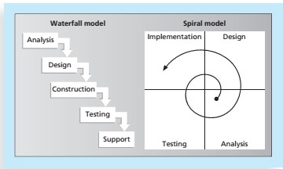

Adaptive Software Development (ASD) Life Cycle
- In contrast to the predictive models, the adaptive software development (ASD) life cycle model assumes that software development follows an adaptive approach because the requirements cannot be clearly expressed early in the life cycle.
- An adaptive approach is also used to provide more freedom than the prescriptive approaches.
- It allows development using a more free-form approach to create components that provide the functionality specified by the business group.
- Important attributes of this approach are that the projects are mission driven and component based, using time-based cycles to meet target dates.
- Requirements are developed using an iterative approach, and development is risk driven and change tolerant to address and incorporate risks rather than mitigate them.
Adaptive Software Development Agile Software Development
- The term agile software development has become popular to describe new approaches that focus on close collaboration between programming teams and business experts.
- Agile approaches are used in rapid software development and to handle frequent system changes and maintenance to production systems.
Agile Software Development
- Because many of these changes might be relatively minor, the more traditional project approaches would take much longer and cost more.
- Agile techniques have an iterative, short-cycle focus on delivery of working software.
The Importance of Project Phases and Management Reviews
- Due to the complexity and importance of many IT projects and their resulting products, it is important to take time to review the status of a project at each phase.
- A project should successfully pass through each of the main project or product phases before continuing to the next.
The Importance of Project Phases and Management Reviews
Because the organization usually commits more money as a project continues, a management review should occur after each phase to evaluate progress, potential success, and continued compatibility with organizational goals.

The Nature of IT Projects
- Unlike projects in many other industries, IT projects can be very diverse.
- Some involve a small number of people installing off-theshelf hardware and associated software.
- Others involve hundreds of people analyzing several organizations’ business processes and then developing new software in a collaborative effort with users to meet business needs.
- Even for small hardware-oriented projects, a wide diversity of hardware types could be involved e.g. personal computers, mainframe computers, network equipment, kiosks, laptops, tablets, or smartphones, to name a few.
- The network equipment might be wireless, phonebased, cable-based, or require a satellite connection.
- The nature of software development projects is even more diverse than hardware-oriented projects.
- A software development project might include creating a simple, stand-alone Microsoft Excel or Access application, or a sophisticated, global e-commerce system that uses state-of-the-art programming languages and runs on multiple platforms
- Because of the diversity of IT projects and the newness of the field, it is important to develop and follow best practices in managing these varied projects.
- That way, IT project managers will have a common starting point and method to follow with every project.
Characteristics of IT Project Team Members
Even with different educational backgrounds, there are common job titles for people working on most IT projects, such as business analyst, programmer, network specialist, database analyst, quality assurance expert, technical writer, security specialist, hardware engineer, software engineer, and system architect. Within the category of programmer, several other job titles describe the specific technologies used.

Chapter 2
Software/IT Project Appraisal

Introduction
- An important consideration in any IT project, whether it is the development of a new system or an investment in new infrastructure, is the business case.
- It has been increasingly recognized that the achievement of business benefits should drive projects.
Business Case Development and Approval
- A business case provides the information required for an organization to decide whether a project should proceed.
- Depending on the organization and often on the size of the investment, the development of a business case is either the first step in a project or a precursor to the commencement of a project.
Business Case Development and Approval
- The initial business case would normally derive from a feasibility study undertaken as part of project initiation/planning.
- Feasibility study is an early study of a problem to assess if a solution is practical, meets requirements within established budgets and schedule requirements.
Feasibility Study
- The development of a new computer system is a major project and is likely to be costly in both resources and money, and will probably cause disruption during development and implementation.
- The project is also likely to have a major effect on the way that the organisation operates.
- Feasibility study is carried out to help provide answers to the following questions:
  - What is required of the system?
  - How can the requirements be satisfied?
  - Is it technically feasible?
  - Is it worth doing?
  - Will the organisation have to change its ways of doing business. Feasibility study will normally include the following six elements:
  - Project Scope.
  - Current Analysis.
  - Requirements.
  - The approach.
  - Evaluation.
  - Formal Review.
Project Scope
- The project scope defines the business problem and/or opportunity to be addressed.
- It should be clear, concise and to the point.
Current Analysis
- This defines and establishes an understanding of a system, a software product.
- Based on this analysis, it may be determined that the current system or software product is working correctly, some minor modifications are needed, or a complete upgrade or replacement is required.
- At this point in the process, the strengths and weaknesses of the current system or software product are identified.
Requirements Definition
- Requirements are defined based upon stakeholder needs and constraints.
- Defining requirements for software differs from defining requirements for systems.
- Examples of needs and constraints used to define requirements:
  - Business, contractual and regulatory processes.
  - End-user functional needs.
  - Technical and physical attributes defining operational and engineering parameters.
The Approach
- This is the recommended system and/or software solution to satisfy the requirements.
- This step clearly identifies the alternatives that were considered and the rationale as to why the preferred solution was selected.
- This is the process wherein the use of existing structures and commercial alternatives are considered (e.g. build versus buy decisions).
Evaluation
- This is based upon the previously completed elements with the feasibility study.
- The final report addresses the cost-effectiveness of the approach selected.
- Elements of the final report include:
  - The estimated total cost of the project if the preferred solution is selected along with the alternatives to provide a cost comparison including:
  - Estimate of employee hours required to complete, material and facility costs, vendors and third party contractors costs, project schedule start and end dates, a cost and evaluation summary encompassing cost-benefit analysis.
Formal Review
A formal review of the feasibility study report is conducted with all stakeholders.
This review will both validate the completeness and accuracy of the feasibility study and render a decision to either approve or reject the project or ask for corrections before making a final decision.
Formal Review
If the feasibility study is approved, all key stakeholders sign the document.
Rationale for rejection of the feasibility study should be explained and attached to the document as part of a lessons learned lists for use in future project studies.
Feasibility study
- Before carrying out a feasibility study, the people involved must know what is expected of them.
- This is set out in a formal document called the Terms of Reference (ToR). ToR document will contain the following tasks:
  - To define what is required of the system?
  - To investigate the existing system, estimating its costs and any problems or short comings.
  - To explore alternative ways of satisfying the system requirement.
Terms of Reference
- To select the most suitable way of satisfying those requirements.
- To prepare a detailed estimate of the cost of developing and operating the system.
- To assess and assign a value to the savings and benefits of running the new system.
- To compare the costs and benefits of developing the systems.
- To recommend whether or not the project should be carried out.
- To prepare a detailed time schedule for implementing the system.
- To specify performance criteria for the system.
- To recommend suitable candidates for the study group assigned to help in the development of the system.
Stages of the feasibility Study
- Formation of the steering committee.
- Setting of the terms of reference.
- Formation of the study group.
- Planning the study.
- Problem definition and information gathering.
- Project identification.
- Cost benefit analysis.
- Producing a feasibility study report.
Formation of the study Group
The steering committee may appoint a system analysts who will then approach people who possess the requisite abilities and experience.
Planning the study
- A program of work is drawn by the project team, with clearly defined timescales and lines of responsibilities.
- A level of flexibility should be built to allow the feasibility study to cover a wide range of activities.

Information Gathering
This stage produce a formal list of the systems requirements, constraints and problems.
- This will require gathering a great deal of information.
- The list of problems and requirements is likely to cover the following areas:
- The data input to the system.
- The output including the contents, level of details and timing.

- The predicted future volumes of transactions and data to be processed.
- Technical feasibility.
- The organizational structure of the user department and their support staff.
- The operational costs of the current system.
- The current hardware and software available together with the list of the current applications using the hardware and software.

Project identification
This will enable the feasibility study group to suggest various options for the project
Eliminate unsuitable options and evaluate the others.
When selecting how to develop the system, select a number of criteria that the system must satisfy e.g. the speed and volume of processing, compatibility with other systems and the need for security.
Cost-Benefit analysis
- For a project to be carried out, the investment criteria set by the organisation must be satisfied. E.g. a criteria might specify that each project must have an internal rate of return of more than 15%.
- Each of project proposals still under consideration will be the subject of analysis, comparing costs of developing a system with its likely benefits.
- In practice, the evaluation of both costs and benefits can be difficult.
- The different elements of costs may be hard to define and the benefits speculative and hard to quantify.
Main features to be examined in Assessing Project feasibility
To be feasible, a project should be justified on the following grounds:
- Economic feasibility study.
- Technological feasibility study.
- Operational feasibility study.
- Social feasibility study.
Economic Feasibility
- The costs can be broken down into 3 basic categories:
- One-off costs e.g. hardware purchase costs, software purchase costs.
- On-going costs e.g. operating staff salaries, training, cost of security equipment’s.
- Intangible costs. These are harder to quantify e.g. staff dissatisfaction, dysfunctional behaviour, opportunity costs, lock-in costs, incompatibility between other systems operating within the organisation and the new system.
- Benefits also range from easily quantified to those that are more difficult to quantify.
- It is impossible to give a complete list of the possible benefits to be derived from a computer system.
- Each system is unique in the benefits it offers.
- However, benefits can be put into two categories:
  - Direct benefits/cost savings.
  - Indirect (intangible) benefits.
Examples of direct benefits
- Savings resulting from the old system no longer operating e.g. staff salaries and consumables.
- Increased capacity e.g. better management of capital by reducing stock levels and collected debts.
Examples of indirect benefits
- Better and informed decision making.
- Improved customer service.
- Freedom from routine decisions and activities.
- Gaining competitive advantage.
Technological Feasibility
The organisation must have the technological ability to cope with the requirements of the system within the allocated budget.
The hardware and software must be capable of dealing with volumes of transactions and required response time, without significant degradation of the existing systems, or there must be enough money available to upgrade the current facilities.
Operational feasibility
The system must fit with the way that the organisation runs its business and plans to run its business in the future.
It must be capable of providing each user with the required information in a timely manner.
Social feasibility
The system must be compatible with the social organisation/company and the company must be sufficiently sophisticated to be able to deal with the complexity of the system being suggested.
This can be split into 3 basic areas:
- The suggested system should not threaten industrial and personal relations and motivations.
- The system must not conflict with the corporate ethics and way of doing business.
- The skills and the experience within the organisation must be at a high enough level to be able to cope with the complexities of the system.
Justifying Investment in New Technology
Much of the difficulty companies have in new technology comes from the techniques traditionally used to make budgeting decisions.
Traditional capital budgeting techniques are:
- Payback Period
- Return On Investment ( ROI )

Payback Period
This calculates the length of time that an investment takes to pay for itself.
- It is easy to calculate and favours low-risk investments, but it ignores cash flows after the investment has paid for itself.
- Although crude, it is extensively used.
Also used in combination with other methods

Payback Period – Example
Project
1
Project
2
Cost
Kshs
100
,
000
150
,
000
Net
Savings
Year
1
50
,
000
20
,
000
Year
2
50
,
000
70
,
000
Year
3
50
,
000
70
,
000
Year
4
50
,
000
70
,
000
Year
5
0
70
,
000
- Project 1 has paid back at the end of the second year, whereas Project 2 does not recover its investment until near the end of the third year.
- By this criterion, Project 1 is the better investment, whereas the total profit from Project 2 is greater.
Return on Investment
ROI calculates the profits on a project as a percentage of the money investment in it.

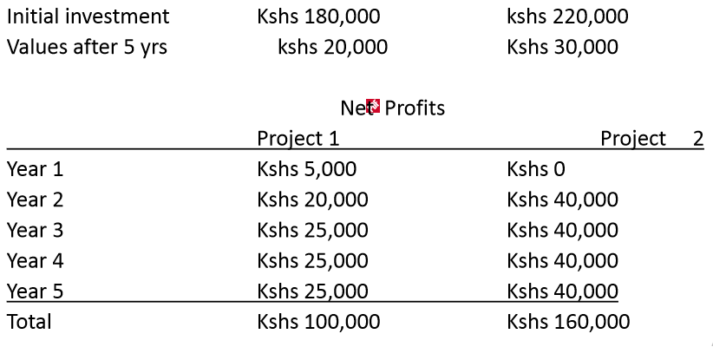
Return on Investment
To calculate the ROI the formula below is used


First, calculate the average profits by finding the total profits and dividing by the number of years.
- Average profit for project 1 = Kshs 20,000 p.a.
- Average profit for project 2 = Kshs 32,000 p.a

Secondly, calculate the average investment. Assuming a straight-line depreciation, this is just the average of the initial investment and the final value.
Third, calculate the ROI: for project 1 = 20% for project 2 = 25.6 %
On this basis, project 2 is a better investment.

ROI
ROI is easy to calculate but ignores the timescale in which the money is earned.
Early income can be reinvested, whereas later income is devalued by the rate of inflation.
Discounted Cash Flow (DCF) Methods
These methods take into consideration the time value of money.
The two principal methods of project appraisal are:
- Net Present Value
- Internal Rate of Return
Net Present Value (NPV)
- This takes the discounted present value of the future cash flows generated by the project, less the initial outlay.
- If the NPV is equal to, or greater than zero, the project should be considered, as it will enhance the value of the firm.
- When using this method to compare projects, the one with the largest NPV should be selected.
Internal Rate of Return (IRR)
This identifies the rate of return that produces an NPV of zero for the project.
If the IRR of the project is greater than the firm’s required rate of return (usually the cost of capital), it should proceed with the project.

Chapter 3
Project Planning and Scheduling
Project Planning
- A plan is a listing or visual display that results when all project activities have been subjected to estimation, logical sequencing and time analysis.
- Some form of network analysis is usually the preferred method for preparing a plan.
- However, some charting methods provide better visual aids and can be more effective for communicating plans to project personnel.
Project Planning
Project planning determines a project schedule based on:
- Project constraints e.g. delivery, staff and Budget.
- Project parameters e.g. structure, size and functions.
- Project milestones and deliverables.
Project planning and scheduling must estimate the risk associated with each decision.
Scheduling involves separating work into tasks and predicting task completion.
The schedule must be revised periodically with progress.
Types of Project plans
Quality plan: This describes the quality procedures and standards that will be used in the project.
Validation plan: Describes the approach, resources and schedule used for system validation.
Configuration management plan: Describes the configuration management procedures and structures to be used.
Maintenance plan: Predicts the maintenance requirements of the system, maintenance cost and effort required.
Staff development plan: This describes how the skills and the experience of the project team members will be developed.
Work Breakdown Structure (WBS)
- A structure used to divide projects into manageable tasks.
- Creating a WBS requires that phases be decomposed into activities, and activities into tasks.
- Each task should be defined at the appropriate level of detail.
Work Breakdown Structure (WBS)
Some tasks may be performed in parallel while others must follow one another sequentially.
Task sequence depends on the following:
- Which tasks produces deliverables needed into other tasks.
- Constraints placed on the project by client.
- Process outlined in the development life cycle.
Guidelines for Defining a Task
A task should:
- Be done by one person or a well-defined group.
- Have a single and identifiable deliverable.
- Have a known method of technique.
- Have a well-accepted predecessor and successor steps.
- Be measurable so that percentage completed can be determined.
Advantages of WBS
- It reduces the complexity of the project since a large or complicated project may be considered as a collection of small projects.
- It helps in resource allocation because different phases will require a different type of resources or skills.
- It helps in monitoring project progress because the completion of a phase may be regarded as a key milestone.
Sample Work Breakdown Structure
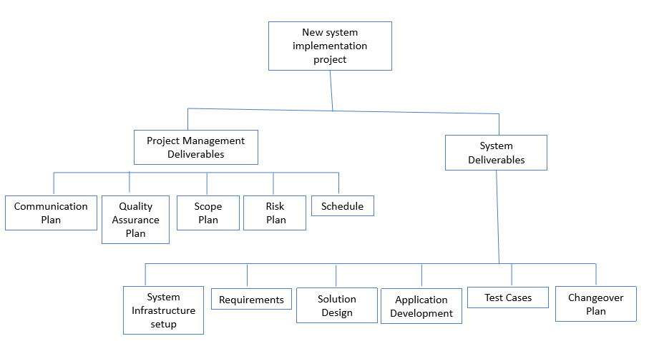

Gantt Charts
This is a visual representation of the project activities and their durations. The vertical axis represents the activities, and the horizontal axis represents the duration.
Example:
- The table in the next slide represents a software project specification with estimated project activity durations, and their precedence requirements. Draw a Gantt chart for the project.
Project specifications
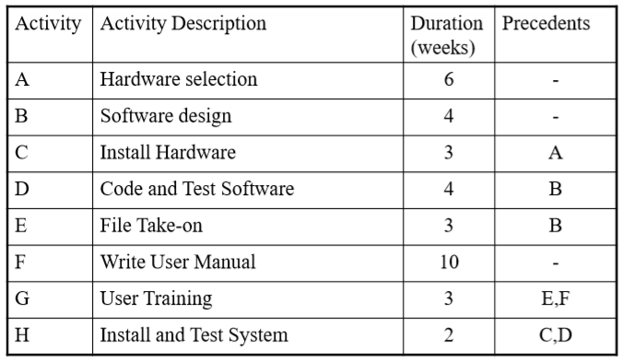

Gantt Chart for the Project
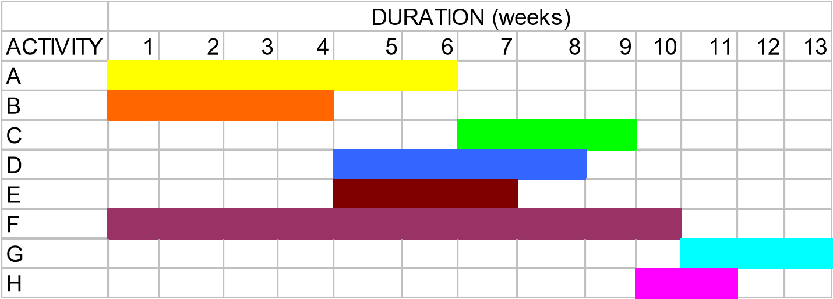
Estimated Project Duration = 13 Weeks
Note: One can use different styles, shades for the duration.

Network Analysis Diagrams
Two types:
- Activity-on-Arrow (AoA) Diagrams.
- Activity-on-Node (AoN) Diagrams.
Activity-on-Arrow (AoA) Diagrams
The diagram represents activities by links or arrows and the nodes represents events of activities as groups of activities start or finishing.
Rules and conventions are:
- A project network diagrams may have only one start node.
- Project network diagram may have only one end-node.
- A link has duration.
AoA Rules
- Nodes have no duration. Nodes are events and are therefore instantaneous points in time.
- The source node is the event of the project becoming ready to start and the sink node is the event of the project becoming completed.
- Intermediate nodes represents 2 simultaneous events i.e.. The event of all activities leading into a node having been completed, and the event of all activities leading out of those nodes being in a position to be started.
Rules and Conventions for AoA
- Time moves from left to right.
- Nodes are numbered sequentially.
- A network may not contain loops.
- A network may not contain dangles.
Activity-on-Arrow Diagram
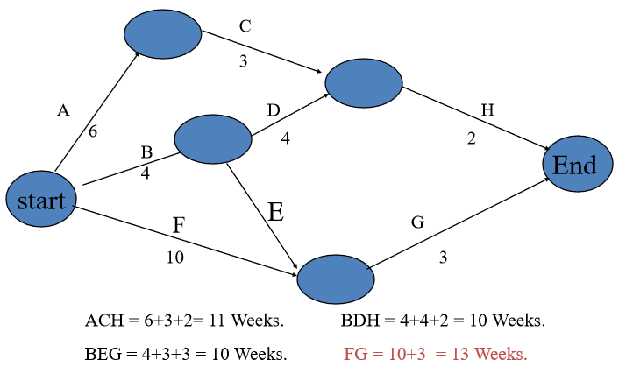

Activity-on-Node diagrams
- The arrows represent the event and the node represent the activity.
- The meaning of arrows and the nodes are directly opposite to that of Activity-on-Arrow diagrams.
- Project Evaluation and Review Technique (PERT) and Critical Path Modeling are two popular quantitative analysis techniques that are used with the AoN diagrams.
- These techniques help managers to plan, schedule, monitor and control large and complex projects.
- The critical path consists of the activities that are important and their delay will affect the entire project completion time.
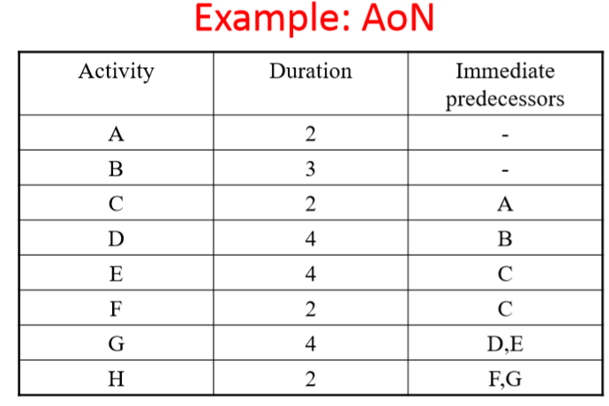
AoN Diagram
FINISH
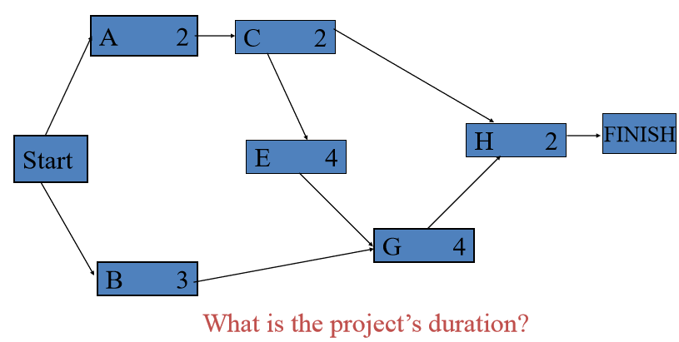

New and/or Unique Projects
- For new or unique projects, providing activity time estimates is not always easy.
- Without solid historical data, project managers are usually uncertain on the activity times.
- For this reason, the developers of PERT employed a probability distribution based on the following time estimates:
  - Optimistic time (a).
  - Pessimistic time (b).
  - Most-likely time (m).
  - Expected activity time (t).
  - variance
Time Estimates
Optimistic Time (a): this is the time that an activity will take if everything goes as well as possible.
Pessimistic Time (b): The time an activity would take assuming very unfavourable conditions.
Most-Likely Time (m): Most realistic time estimate to complete the activity.
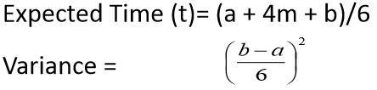
Finding the Critical Path
- Path refers to a series of connected activities ( or intermediate events) between two events in a network.
- Critical path refers to the set of activities on a path from the project’s start event to its finish event, if delayed, will delay the completion date of the project.
- Once the expected completion time for each activity ha been determined, it is accepted as the actual time of the task.
- To find the critical path, the following times are calculated for each activity:
  - Earliest start/event time (ES).
  - Earliest Finish Time (EF).
  - Latest start time (LS).
  - Latest finish time (LF).
Calculating Earliest Activity Times:
- Forward Pass
- Earliest Start time is the earliest time an activity can begin without violation of immediate predecessor requirements.
- ES = largest of the earliest finish times of immediate predecessors
- Earliest Finish Time is the earliest time an activity can end.
- EF = Earliest start time + expected activity time = ES + t.
- Before any activity can begin, all of its predecessor activities must be completed i.e. the largest EF for all of the immediate predecessor, used in determining ES.
- Backward/Reverse Pass
- Latest Start Time is the latest time an activity an begin without delaying the entire project.
  - LS = latest finish time – activity time
  - LS = LF – t
- Since all immediate predecessors must be finished before an activity can begin, the latest start time for an activity determines the latest Finish time for its immediate predecessors.
- Latest Finish time is the latest time an activity can end without delaying the entire project.
- LF = smallest of latest start times for following activities.

Notation
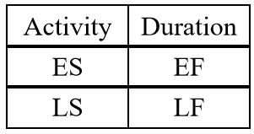 | 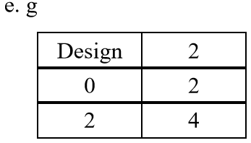

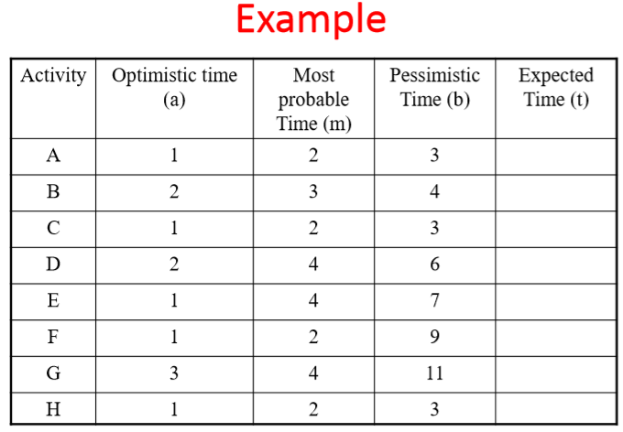

Chapter 4
Project Monitoring and Control
Introduction
- Once the work schedules have been published and the project is underway, attention is focused on ensuring progress.
- This requires monitoring of what is happening, comparison of actual achievement against the schedule and, where necessary, revision of plans and schedules to bring the project as far as possible back on target.
Creating a framework
Exercising control over a project and ensuring that targets are met is a matter of regular monitoring, finding out what is happening, and comparing it with current targets.
If there is a mismatch between the planned outcomes and the actual ones then either replanning is needed to bring the project on target or the target will have to be revised.
In practice, we are normally concerned with departures from the plan in four dimensions:
- Delays in meeting target dates.
- Shortfalls in quality.
- Inadequate functionality, and
- Costs going over target.

Project Control Cycle

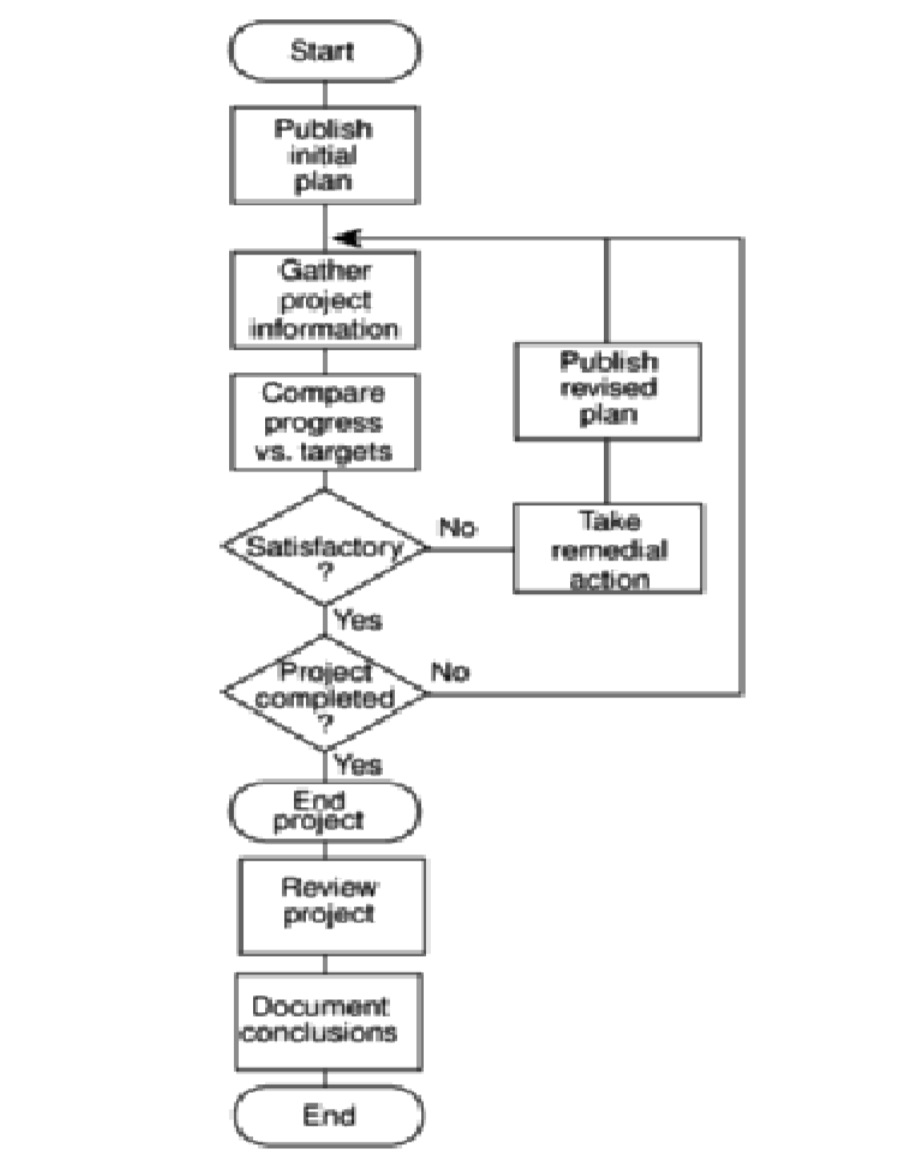
Responsibility for Control
- The overall responsibility for ensuring satisfactory progress on a project is often the role of the project steering committee or project board.
- Day-to-day responsibility will rest with the project manager and, in all but the smallest of projects, aspects of this can be delegated to team members.

- Reporting may be oral or written, formal or informal, or regular or ad hoc.
- While any effective team leader or project manager will be in touch with team members and available to discuss problems, any such informal reporting of project progress must be complemented by formal reporting procedures.
Assessing Progress
This will normally be made on the basis of information collected and collated at regular intervals or when specific events occur.
Whenever possible, this information will be objective and tangible.
Setting Checkpoints
It is essential to set a series of checkpoints in the initial activity plan.
Checkpoints may be:
- Regular (e.g. monthly)
- Tied to specific events such as the production of a report or other deliverable.
Taking Snapshots
The frequency with which the project manager needs to receive information about progress will depend upon the size and degree of risk of the project or that part of the project under their control.
E.g. team leaders need to assess progress daily whereas project managers may find weekly or monthly reporting appropriate.
Collecting Data
As a rule, managers will try to break down long activities into more controllable tasks of one or two week’s duration.
However, it will still be necessary to gather information about partially completed activities and, in particular, forecasts of how much work is left to be completed.

A Weekly time sheet and progress review form
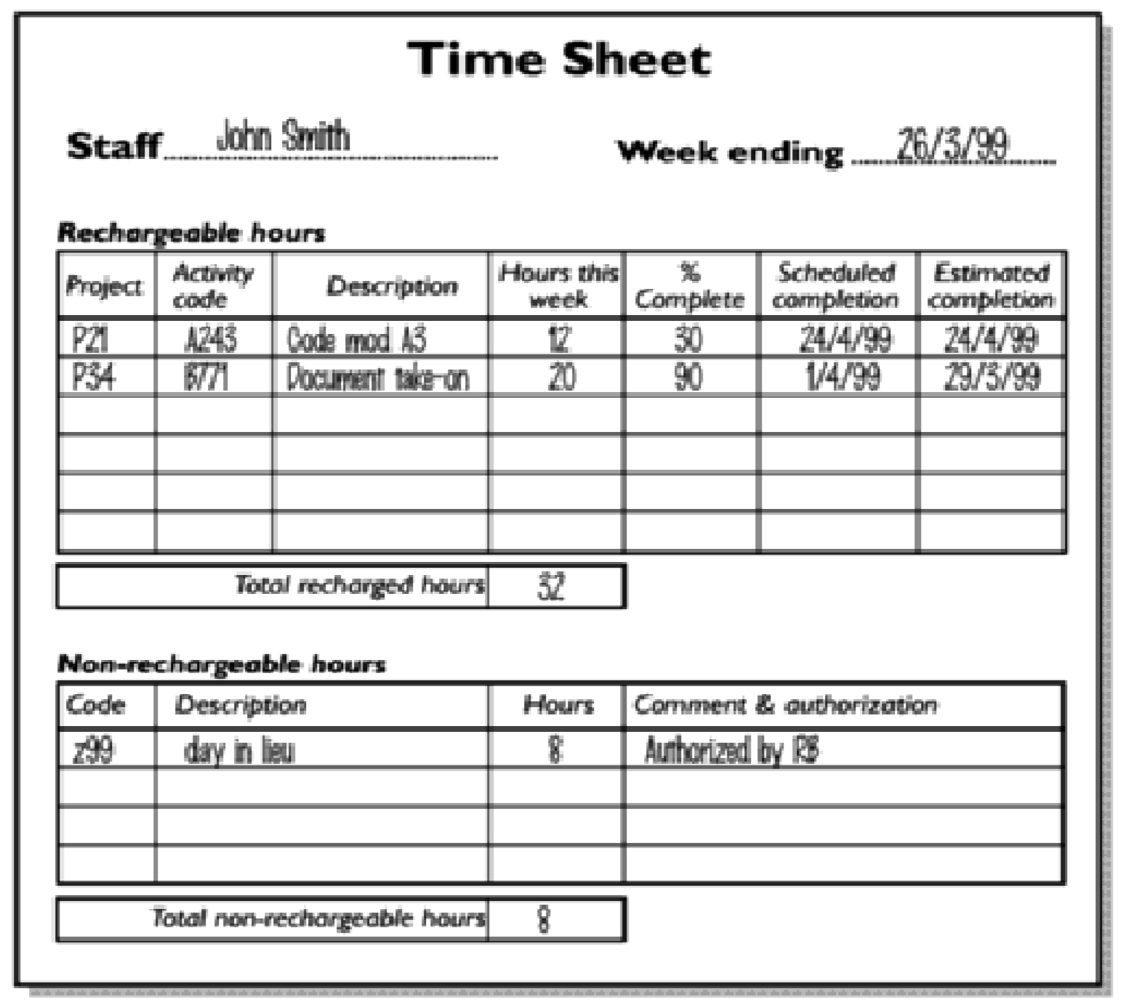
Cost Monitoring
- Expenditure monitoring is an important component of project control.
- Not only in itself, but also because it provides an indication of the effort that has gone into (or at least been charged to) a project.
- A project might be on time but only because more money has been spent on activities than originally budgeted.
- Project costs may be monitored by a company’s accounting system.

Prioritizing Monitoring
Monitoring takes time and uses resources that might sometimes be put to better use.
Priority that might be applied in deciding levels of monitoring are:
- Critical path activities.
- Activities with no free float.
- Activities with less than a specified float.
- High risk activities.
- Activities using critical resources.
Critical path activities
- Any delay in an activity on the critical path will cause a delay in the completion date for the project.
- Critical path activities are therefore likely to have a very high priority for close monitoring.
Activities with no free float
- A delay in any activity with no free float will delay at least some subsequent activities even though, if the delay is less than the total float, it might not delay the project completion date.
Activities with less than a specified float
- If any activity has very little float, it might use up this float before the regular activity monitoring brings the problem to the project manager’s attention.
- It is common practice to monitor closely those activities with less than , say, one week free float.
High risk activities
- A set of high risk activities should have been identified as part of the initial risk profiling exercise.
- If PERT three-estimate approach is being used, a high risk activities are those that have a high estimated duration variance.
- These activities will be given close attention because they are most likely to overrun or overspend.
Getting Project back on target
Almost any project will, at one time or another, be subject to delays and unexpected events.
One of the tasks of the project manager is to recognize when this is happening (or, if possible, about to happen) and, with the minimum delay and disruption to the project team, attempt to mitigate the effects of the problem.
In most cases, the project manager tries to ensure that the scheduled project end date remains unaffected.
This can be done by shortening:
  - Remaining activity durations or
  - The overall duration of the remaining project.
- Shortening Critical Path
The overall duration of a project is determined by the current critical path, so speeding up non-critical path activities will not bring forward completion date.
- Reconsider the precedence requirements
If attempting to shorten critical activities proves insufficient, the next step is to consider the constraints by which some activities have to be deferred pending completion of others.
The original project network was most probably drawn up assuming “ideal” conditions and “normal” working practices.
One way to overcome precedence constraints is to subdivide an activity into a component that can start immediately and one that is till constrained as before.
Remember that shortening activity durations might not always be the most appropriate response to disruptions to a plan.
There is little point in spending considerable sums in overtime payments in order to speed up a project if the customer is not overly concerned with the delivery date and there is no other valuable work for the team members once this project is completed.
Changes in Projects
- Change is inevitable when computer software is built.
- This increases the level of confusion among software engineers who are working on a project.
- Confusion arises when changes are not:
  - Analyzed before they are made.
  - Recorded before they are implemented.
  - Reported to those with a need to know.
  - Controlled in a manner that will improve quality and reduce error.
Sources of Change
- New business or market conditions that dictate changes in product requirements or business rules.
- New customer needs that demand:
  - Modification of data produced by information systems.
  - Functionality delivered by products.
  - Service delivered by a computer-based system.
- Reorganization and/or business downsizing that causes changes in project priorities or software engineering team structure.
- Budgetary or scheduling constraints what cause a redefinition of the system or product?

What is configuration Management?
- The process of identifying and defining the items in the system, controlling the changes to these items throughout their life cycle, recording and reporting the status of items and change requests, and verifying the completeness and correctness of items.
- The art of identifying, organizing, and controlling modifications to the software being built by a programming team.
- The goal is to maximize productivity by minimizing mistakes.
Functions of configuration Management
- Identification: Unique naming of the software objects to be managed.
- Control: Controlling the release of a product and changes to it throughout the software life cycle.
- Status accounting: Recording and reporting the status of components and change requests.
- Audit and review: Validating the completeness of a product and maintaining consistency among the components.
- Manufacture: Managing the construction and building of a product.
- Process management: Ensuring the carrying out of the organization’s procedures, policies, and life cycle model.
- Team work: Controlling the work and interactions between multiple users on a product.
Software Maintenance and Software Configuration Management
- Software Maintenance: A set of software engineering activities that occur after software has been delivered to the customer and put into operation.
- Software Configuration Management: A set of tracking and control activities that begin when a software project begins and terminate only when the software is taken out of operation.
Purpose of Configuration Management
- Change to an existing software system are inevitable. Configuration management ensures that these changes:
  - Take place in an identifiable and controlled environment.
  - Do not adversely affect any properties of the system.
  - Do not adversely affect the implementation of the security policy.
- It provides assurance that additions, deletions or changes made do not compromise the trust of the originally evaluated system.
- This identifies the components of the design and implementation of a system.
Configuration Identification
This task may be accomplished through the use of:
- Identifiers.
- Baselines.
Baseline
- This is a Software Configuration Management concept that helps to control change without seriously impeding justifiable change.
- It is a specification or product that has been formally reviewed and agreed upon, that thereafter serves as the basis for further development, and that can be changed only through formal change control procedures.
Baselining
- Software engineering tasks produce one or more Software Configuration Items (SCIs).
- SCI are reviewed and approved, SCIs placed in a project database (also called project library/software repository).
- When a member of a software engineering team wants to make modifications to a baselined SCI, it is copied from the project database into the engineer’s workspace.
- The SCI can only be modified if SCM controls are followed.

The SCM tasks
- Identification.
- Version Control.
- Change Control.
- Configuration Auditing.
- Reporting.
Identification
- To control and manage software configuration items, each must be separately named and then organized.
- Two types of objects can be identified:
  - Base objects: A ‘unit of text’ created by a software engineer during analysis, design, coding, or testing. E.g. a section of a requirements specification.
  - An aggregate object: a collection of basic objects and other aggregate objects. E.g. design specification.
- Each object has a set of distinct features that identify it uniquely:
  - Name
  - Description
  - Resources.
  - A “realization”: a pointer to the ‘unit of text’ for a basic object or null for an aggregate object.
- Identification must also consider the relationships that exist between named objects.

Configuration Control
- Involves a systematic:
  - Evaluation.
  - Coordination.
  - Approval or disapproval.
- It begins in the earliest stages of the design and development of the system and extends over the full life of the configuration items included in the design and development stages.
- Early initiation of configuration control procedures provides increased accountability for the system by making its development more traceable.
- This early initiation serves a dual purpose:
  - It makes it possible to evaluate the impact of a change to the system and controls the change as it is being made.
  - There is less chance of making undesirable changes to a system that may later adversely affect the security of the system.
  - It specifies procedures to ensure that all documentation is updated properly and presents an accurate description of the system and software configuration.
  - It covers a broader area than just documentation.
  - It maintains control of design data, source code, the running version of the object code, and test fixtures.
  - Changes to any of these are subject to review and approval by an authorized authority.

Configuration Status Accounting
- Used in reporting on the progress of the development in very specific ways.
- It accomplishes this task through:
  - Data recording.
  - Data storing.
  - Data reporting.
- Objective is to record and report all information that is of significance to the configuration management process.
- It establishes records and reports which enable proper logistics support to be established.
- The records and reports produced through configuration status accounting should include:
  - A current configuration list.
  - A historical change list.
  - The original designs.
  - The status of change requests and their implementation.
  - The ability to trace all changes.
Configuration Audit
Configuration Auditing:
- This is the checking for top to bottom completeness of the configuration accounting information to ascertain that only the authorized changes have been made.
- A change should be reviewed and audited for its effect on the rest of the system.
- Configuration audits should be performed periodically.
- It should verify that:
  - The architectural design satisfies the requirements.
  - The detailed design satisfies the architectural design.
  - The code implements the detailed design.
  - The item/product performs per the requirements.
  - The configuration documentation and the item/product match.
Configuration Management Plan
Procedures:
- Procedures to ensure that both user and design documentation are updated in synchrony with all changes to the system.
- Guidelines for creating and maintaining functional tests and documentation throughout the life of the system.
- Procedures for how the design and implementation of changes are proposed, evaluated, and approved or disapproved.
- Steps to take to ensure that only those approved changes are actually included and that the changes are included in all of the necessary areas.
- Emergency procedures.
Defines:
- Types of documents to manage and a document naming scheme.
- Who takes responsibility for CM procedures and creation of baselines.
- Policies for change control and version management.
- Tools which can be used to assist the CM process and their limitations.
- The CM database used to record configuration information.

Chapter 5
Software Quality Management
Chapter Objectives
- Describe quality management and key quality management activities.
- Explain the roles of standards in quality management.
- Describe the concept of a software metric, predictor metrics and control metrics.
- Explain how measurement may be used in assessing software quality.
What is Software Quality Assurance (SQA)?
- Conformance to explicitly stated functional and performance requirements, explicitly documented development standards, and implicit characteristics that are expected of all professionally developed software.
- Software Quality Assurance (SQA) - A planned and systematic approach to the evaluation of the quality of and adherence to software product standards, processes and procedures.
SQA
It includes:
- Assuring that standards and procedures are established and are followed throughout the software acquisition life cycle.
- Compliance with agreed-upon standards and procedures is evaluated through process monitoring, product evaluation and audits.
Emphasis of the definitions
- Software requirements are the foundation from which quality is measured. Lack of conformance to requirements is lack of quality.
- Specified standards define a set of development criteria that guide the manner in which software is engineered. If the criteria is not followed, lack of quality results.
- There is a set of implicit requirements that often goes unmentioned e.g the desire for good maintainability. If software conforms to its implicit requirements, software quality is suspect.
Software Quality Management
- Concerned with ensuring that the required level of quality is achieved in a software product.
- Involves defining appropriate quality standards and procedures and ensuring that these are followed.
- Quality management is therefore not just concerned with reducing defects but also with other product qualities.
What is Quality?
- Simplistically -A product should meet its specification.
- This definition is problematic for software systems since:
  - Tension between customer quality requirements (efficiency, reliability) and developer quality requirements (maintainability, reusability)
  - Some quality requirements are difficult to specify in an unambiguous way.
  - Software specification are usually incomplete and often inconsistent.
The quality Compromise
- Software developers cannot wait for specifications to improve before paying attention to quality management.
- Procedures must be put into place to improve quality in spite of imperfect specification.

Quality Compromise
- Quality management is therefore not just concerned with reducing defects but also with other product qualities.
Quality management Activities
- Quality Assurance
- Quality planning
- Quality Control
Quality Assurance: Establish organizational procedures and standards for quality.
Quality Planning: Select applicable procedures and standards for a particular project and modify these as required.
Quality Control: Ensure that procedures and standards are followed by the software development team.
- Note:
  - Quality management should be separate from project management to ensure independence.
Standards
Definition: Established criteria to which the software products are compared.
Standards Organizations
- Software Engineering Institute: Develops standards that help improve software development processes.
- International Standards Organisation (ISO): concerned with quality systems that are assessed by outside auditors.
- Institute of Electrical and Electronics Engineers (IEEE): standards for devices.
- American National Standards Institute (ANSI).

ISO 9000
- International set of standards for quality management. Applicable to a range of organisations from manufacturing to service industry.
- ISO 9001 applicable to organisations which design, develop and maintain products.
- ISO 9001 is a generic model of the quality process and must be instantiated for each organisation.
Quality Assurance and Standards
- Standards are the key to effective quality management.
- They may be international, national, organizational or project standards.
- Product standards define characteristics that all components should exhibit e.g. common programming style.
- Process standards define how the software process should be enacted.
Importance of Standards
- Encapsulation of best practice: this helps in avoiding repetition and mistakes.
- Framework for quality assurance process: it involves checking standard compliance.
- Provide continuity: New staff can understand the organisation by understanding the standards applied.
Problems with standards
- Not seen as relevant and up-to-date by software engineers.
- Involve too much bureaucratic form filling.
- Unsupported by software tools, so tedious manual work is involved to maintain standards.

Standards Development
- Involve practitioners in development.
- They should understand the rationale underlying a standard.
- Review standards and their usage regularly.
- Standards can quickly become outdated and this reduces their credibility amongst practitioners.
- Detailed standards should have associated tool support.
- Excessive clerical work is the most significant complaint against standards.
Documentation standards
Particularly important – documents are the tangible manifestation of the software.
Documentation process:
- Are concerned with how documents should be developed, validated and maintained.
- Document standards: are concerned with document contents, structure, and appearance.
- Document interchange standards are concerned with how documents are stored and interchanged between different documentation
- Document identification standards: How documents are uniquely identified.
- Document structure standards: Standard structure for project documents.
- Document presentation standards: Define fonts and styles, use of logos
- Document update standards: Define how changes from previous versions are reflected in a document.
Document Interchange Standards
- Documents are produced using different systems and on different computers.
- Interchange standards allow electronic documents to exchange.
- Need for archiving.
- The lifetime of word processing systems may be much less than the lifetime of the software being documented.
- XML is an emerging standard for document interchange.
Process and Product Quality
- The quality of a developed product is influenced by the quality of the production process.
- Particularly important in software development as some product quality attributes are hard to assess.
- However, there is a very complex and poorly understood relationship between software processes and product quality.
Process-based quality
- There is a straight-forward link between process and product in manufactured goods.
- It is more complex for software because:
- The application of individual skills and experience is particularly important in software development.
- External factors such as the novelty of an application or the need for an accelerated development schedule may impair product quality.
- Care must be taken not to impose inappropriate process standards.
Practical process quality
- Define process standards such as how reviews should be conducted, configuration management, etc.
- Monitor the development process to ensure that standards are being followed.
- Report on the process to project management and software procurement.

Quality Planning
- A quality plan sets out the desired product qualities and how these are assessed and define the most significant quality attributes.
- It should:
  - Define the quality assessment process.
  - Set out which organizational standards should be applied and if necessary, define new standards.
Structure of a Quality Plan
- Product introduction
- Product plans.
- Process descriptions.
- Quality goals.
- Risk and risk management.
- Quality plans should be short, succinct documents.
Quality Control
- Checking the software development process to ensure that procedures and standards are being followed.
- Two approaches to quality control are:
  - Quality reviews.
  - Automated software assessment and software measurement.
Quality Reviews
- The principal method of validating the quality of a process or of a product.
- A group examines part or all of a process or system and its documentation to find potential problems.
- There are 3 different types of reviews with different Objectives:
  - Inspections for defect removal(product).
  - Reviews for progress assessment ( product and process).
  - Quality reviews (product and standards).
- A group of people carefully examine part or all of a software system and its associated documentation.
- Code, designs, specifications, test plans, standards can all be reviewed.
- Software or documents may be ‘signed off’ at a review which signifies that progress to the next development stage has been approved by management.
The review process
- Select a review team.
- Arrange place and date.
- Distribute documents.
- Hold review.
- Complete review forms.
Review Functions
Quality function:
- They are part of the general quality management process.
- Project management function:
- They provide information for project managers.
- Training and communication function:
- Product knowledge is passed between development team members.
Quality Reviews
- Objective is the discovery of system defects and inconsistencies.
- Any document produced in the process may be reviewed.
- Review teams should be relatively small and reviews should be fairly short.
- Review should be recorded and records maintained.
Review Results
No action:
No change to the software or documentation is required.
Refer for repair:
- Designer or programmer should correct an identified fault.
- Reconsider overall design:
  - The problem identified in the review impacts other parts of the design. Some overall judgment must be made about the most cost-effective way of solving the problem.
Software Measurements and Metrics
- Software measurement is concerned with deriving a numeric value for an attribute of a software product or process.
- This allows for objective comparisons between techniques and processes.
- There are a few standards in this area.
Software Metric
Definition:
- Any type of measurement which relates to a software system, process or related documentation.
- Allows the software and the software process or product to be quantified.
Measures of the software or product may be used to predict product attributes (predictor metrics) or to control the software process (control metrics).
Metrics Assumptions
- Any software property can be measured.
- The relationship exists between what we can measure and what we want to know.
- This relationship has been formalized and validated.
- It may be difficult to relate what can be measured to desirable quality attributes.

The Measurement Process
- A software measurement process may be part of a quality control process.
- Data collected during this process should be carried as an organizational resource.
- Once a measurement database has been established, comparisons across projects become possible.

Data collection
- A metrics programme should be based on a set of product and process data.
- Data should be collected immediately and if possible, automatically.
- Three types of automatic data collection:
  - Static product analysis,
  - Dynamic product analysis and
  - Process data collection.
Measurement Surprises
- Reducing the number of faults in a program leads to an increased number of help desk calls?
- The program is now thought of as more reliable and so has a wider more diverse market. The percentage of users who call the help desk may have decreased but the total may increase.
- A more reliable system is used in a different way from a system where users work around the faults. This leads to more help desk calls.

CHAPTER 6
SOFTWARE PROJECT RISK MANAGEMENT

Chapter objectives
- Describe the project risk management planning framework introduced in this chapter.
- Define risk identification and the causes, effects, and integrative nature of project risks.
- Apply several qualitative and quantitative analysis techniques that can be used to prioritize and analyze various project risks.
- Describe the various risk strategies, such as insurance, avoidance, or mitigation.
- Describe risk monitoring and control.
- Describe risk evaluation in terms of how the entire risk management process should be evaluated in order to learn from experience and to identify best practices.

Introduction to project Risk
- Project plan is based on a number of estimates that reflect our understanding of the current situation, the information available, and the assumptions we must make.
- The fact that we must estimate implies a degree of uncertainty in predicting the outcome of future events.
- Although no one can predict the future with 100 percent accuracy, having a solid foundation, in terms of processes, tools, and techniques, can increase our confidence in these estimates.
- Unfortunately, things seldom go according to plan because the project must adapt to a dynamic environment.
- Project risk management is becoming an important sub-discipline of software engineering.

What is a Risk?
- Risks are potential problems that may affect successful completion of a software project.
- Risks involve uncertainty and potential losses.
- An uncertain event or condition that, if it occurs, has a positive or negative effect on the project objectives. “Hazard; peril; or exposure to loss or injury

Risks
- This uncertainty comes from our attempt to predict the future based on estimates, assumptions, and limited information.
- Although project risk has a downside resulting from unexpected problems or threats, project risk management must also focus on positive events or opportunities.
- Therefore, it is important that we understand what those events are and how they may impact the project beyond its objectives.
- It is also important that we understand not only the nature of project risks but also how those risks interact and impact other aspects of the project throughout the life of a project.

Categories of Risks
- Project risks
- Product risks
- Business risks

Project Risks
- Risks that affect the project schedule or resources.
- An example of a project risk is the loss of an experienced designer.
- Finding a replacement designer with appropriate skills and experience may take a long time and, consequently, the software design will take longer to complete.

Product Risks
- Risks that affect the quality or performance of the software being developed.
- An example of a product risk is the failure of a purchased component to perform as expected.
- This may affect the overall performance of the system so that it is slower than expected.

Business Risks
- Risks that affect the organization developing or procuring the software.
  - For example, a competitor introducing a new product is a business risk.
The introduction of a competitive product may mean that the assumptions made about sales of existing software products may be unduly optimistic.

Project Risks
- These risk types overlap.
- If an experienced programmer leaves a project this can be a project risk because, even if they are immediately replaced, the schedule will be affected.
- It inevitably takes time for a new project member to understand the work that has been done, so they cannot be immediately productive.
- Consequently, the delivery of the system may be delayed.
- The loss of a team member can also be a product risk because a replacement may not be as experienced and so could make programming errors. Finally, it can be a business risk because that programmer’s experience may be crucial in winning new contracts.
- Risk management focuses on identifying, analyzing, and developing strategies for responding to project risk efficiently and effectively.
What is Risk Management?
- The systematic process of identifying, analyzing, and responding to project risk.
- It includes maximizing the probability and consequences of positive events and minimizing the probability and consequences of adverse events.It is important, however, to keep in mind that the goal of risk management is not to avoid risks at all costs, but to make well-informed decisions as to what risks are worth taking and to respond to those risks in an appropriate manner.
- Project risk management also provides an early warning system for impending problems that need to be addressed or resolved.
- Although risk has a certain negative connotation, project stakeholders should be vigilant in identifying opportunities.
- Although many associate uncertainty with threats, it is important to keep in mind that there is uncertainty when pursuing opportunities, as well.
- It is unfortunate that many projects do not follow a formal risk management approach.
- Because of their failure to plan for the unexpected, many organizations find themselves in a state of perpetual crisis characterized by an inability to make effective and timely decisions.
- Many people call this approach crisis management or firefighting because the project stakeholders take a reactive approach or only address the project risks after they have become problems.
- Risk analysis and management are intended to help a software team understand and manage uncertainty during the development process.

Common mistakes to managing project Risk
- Not Understanding the Benefits of Risk Management.
- Not Providing Adequate Time for Risk Management.
- Not Identifying and Assessing Risk Using a Standardized Approach.
Not Understanding the Benefits of Risk Management
- Often the project sponsor or client demands results.
- They may not care how the project team achieves its goal and objectives—just as long as it does!
- The project manager and project team may rely on aggressive risk taking with little understanding of the impact of their decisions.
- Conversely, project risks may also be optimistically ignored when, in reality, these risks may become real and significant threats to the success of the project.
- Unfortunately, risks are often schedule delays, quality issues, and budget overruns just waiting to happen.
- Risks can result in sub-par productivity and higher than average project failure rates.
Not providing adequate Time for Risk Management
- Risk management and the ensuing processes should not be viewed as an add-on to the project planning process, but should be integrated throughout the project life cycle.
- The best time to assess and plan for project risk, in fact, is at the earliest stages of the project when uncertainty for a project is the highest.
- Catastrophic problems or surprises may arise that require more resources to correct than would have been spent earlier avoiding them.
- It is better to reduce the likelihood of a risk or be capable of responding to a particular risk as soon as possible in order to limit the risk's impact on the project's schedule and budget.

Not Identifying and Assessing Risk using a Standardized Approach
- Not having a standardized approach to risk management can overlook both threats and opportunities.
- Consequently, more time and resources will be expended on problems that could have been avoided; opportunities will be missed; decisions will be made without complete understanding or information; the overall likelihood of success is reduced; and catastrophic problems or surprises may occur without advanced warning.
- Moreover, the project team may find itself in a perpetual crisis mode.
- Over time, crisis situations can have a detrimental effect on team morale and productivity.

Effective and Successful Project Risk Management
Effective and successful project risk management requires:
- Commitment by all stakeholders.
- Stakeholder Responsibility.
- Different Risks for Different Types of Projects.

Commitment by Stakeholders
- To be successful, project risk management requires a commitment by all project stakeholders.
- In particular, the project sponsor or client, senior management, the project manager, and the project team must all be committed.
- For many organizations, a new environment and commitment to following organizational and project processes may be required.
- For many managers, the first impulse may be to shortcut or sidestep many of these processes at the first sign that the project is in trouble.
- A firm commitment to a risk management approach will not allow these impulses to override the project management and risk management processes that the organization has in place.

Stakeholder Responsibility
- It is important that each risk have an owner.
- This owner is someone who will be involved in the project, who will take the responsibility to monitor the project in order to identify any new or increasing risks, and who will make regular reports to the project sponsor or client.
- The position may also require the risk owner to ensure that adequate resources be available for managing and responding to a particular project risk.
- However, the project manager is responsible for ensuring that appropriate risk processes and plans are in place.
Different Risks for Different Types of Projects
- Patterns of risk are different across different types of IT projects.
- The implication is that each project has its own unique risk considerations.
- To attempt to manage all projects and risks the same way may spell disaster.

Risk Management Processes
- Risk Identification:
- Risk Assessment/Analysis.
- Risk Management Planning.
- Risk monitoring and Control.
Risk Identification
- This entails identifying the various risks to the project.
- Both threats and opportunities must be identified.
- When identifying threats to a project, they must be identified clearly so that the true problem, not just a symptom, is addressed.
- Moreover, the causes and effects of each risk must be understood so that effective strategies and responses can be made.
- It is important to keep in mind that project risks are rarely isolated.
- Risks tend to be interrelated and affect the project and its stakeholders differently.

Risks and Risk Types
Risk type | Possible risks
Technology | The database used in the system cannot process as many transactions per second as expected.  Software components which should be reused contain defects which limit their functionality.
People | It is impossible to recruit staff with the skills required.  Key staff are ill and unavailable at critical times.  Required training for staff is not available.
Organisational | The organisation is restructured so that different management are responsible for the project.  Organisational financial problems force reductions in the project budget.
Tools | The code generated by CASE tools is inefficient. CASE tools cannot be integrated.
Requirements | Changes to requirements which require major design rework are proposed.  Customers fail to understand the impact of requirements changes.
Estimation | The time required to develop the software is underestimated.  The rate of defect repair is underestimated.  The size of the software is underestimated.

Software Risks
Risk | Affects | Description
Staff turnover | Project | Experienced staff will leave the project before it is finished.
Management change | Project | There will be a change of organisational management with different priorities.
Hardware unavailability | Project | Hardware that is essential for the project will not be delivered on schedule.
Requirements change | Project and product | There will be a larger number of changes to the requirements than anticipated.
Specification delays | Project and product | Specifications of essential interfaces are not available on schedule
Size underestimate | Project and product | The size of the system has been underestimated.
CASE tool underperformance | Product | CASE tools which support the project do not perform as anticipated
Technology change | Business | The underlying technology on which the system is built is superseded by new technology.
Product competition | Business | A competitive product is marketed before the system is completed.

Risk Assessment
- Risk assessment provides a basis for understanding how to deal with project risks.
- Assessing these risks helps the project manager and other stakeholders prioritize and formulate responses to those risks that provide the greatest threat or opportunity to the project.
- Because there is a cost associated with responding to a particular risk, risk management must function within the constraints of the project's available resources.
- Determine how to deal with the various project risks.
- In addition to resource constraints, an appropriate strategy will be determined by the project stakeholders' perceptions of risk and their willingness to take on a particular risk.
- Essentially, a project risk strategy will focus on one of the following approaches:
  - Accept or ignore the risk.
  - Avoid the risk completely.
  - Reduce the likelihood or impact of the risk (or both) if the risk occurs.
  - Transfer the risk to someone else (i.e., insurance).
- In addition, triggers or flags in the form of metrics should be identified to draw attention to a particular risk when it occurs.
- This system requires that each risk have an owner to monitor the risk and to ensure that resources are made available in order to respond to the risk appropriately.
- Once the risks, the risk triggers, and strategies or responses are documented, this document then becomes the risk response plan.

Risk Assessment/Analysis
- Once the project risks have been identified and their causes and effects understood, the next step requires that we analyze these risks.
- Answers to two basic questions are required:
  - What is the likelihood of a particular risk occurring?
  - What is the impact on the project if it does occur?

Risk Assessment or Analysis
Risk | Probability | Effects
Organisational financial problems force reductions in the project budget. | Low | Catastrophic
It is impossible to recruit staff with the skills required for the project. | High | Catastrophic
Key staff are ill at critical times in the project. | Moderate | Serious
Software components that should be reused contain defects which limit their functionality. | Moderate | Serious
Changes to requirements that require major design rework are proposed. | Moderate | Serious
The organisation is restructured so that different manage ment are responsible for the project. | High | Serious

Risk Planning
- The risk planning process considers each of the key risks that have been identified, and develops strategies to manage these risks.
- For each of the risks, you have to think of actions that you might take to minimize the disruption to the project if the problem identified in the risk occurs.
- You also should think about information that you might need to collect while monitoring the project so that problems can be anticipated.
- Risk planning begins with having a firm commitment to the entire risk management approach from all project stakeholders.
- This commitment ensures that adequate resources will be in place to properly plan for and manage the various risks of the IT project.
- These resources may include:
  - Time.
  - People, and
  - Technology.
- Stakeholders also must be committed to the process of identifying, analyzing, and responding to threats and opportunities.
- Too often plans are disregarded at the first sign of trouble, and instinctive reactions to situations can lead to perpetual crisis management.
- In addition to commitment, risk planning also focuses on preparation.
- It is important that resources, processes, and tools be in place to adequately plan the activities for project risk management.
- Systematic preparation and planning can help minimize adverse effects on the project while taking advantage of opportunities as they arise.

Categories of Risk Strategies

Avoidance Strategies
- Following these strategies means that the probability that the risk will arise will be reduced
- An example of a risk avoidance strategy is the strategy for dealing with defective components.

Minimization Strategies
- Following these strategies means that the impact of the risk will be reduced.
An example of a risk minimization strategy is the strategy for staff illness.

Contingency Plans
- Following these strategies means that you are prepared for the worst and have a strategy in place to deal with it.
- An example of a contingency strategy is the strategy for organizational financial problems.

Risk Management Strategies
Risk | Strategy
Organisational financial problems | Prepare a briefing document for senior management showing how the project is making a very important contribution to the goals of the business.
Recruitment problems | Alert customer of potential difficulties and the possibility of delays, investigate buying-in components.
Staff illness | Reorganise team so that there is more overlap of work and people therefore understand each other’s jobs.
Defective components | Replace potentially defective components with bought in components of known reliability.
Requirements changes | Derive traceability information to assess requirements change impact, maximise information hiding in the design.
Organisational restructuring | Prepare a briefing document for senior management showing how the project is making a very important contribution to the goals of the business.
Database performance | Investigate the possibility of buying a high performance database.
Underestimated development time | Investigate buying in components, investigate use of a program generator

Risk Monitoring
- Risk monitoring is the process of checking that your assumptions about the product, process, and business risks have not changed.
- Once the salient project risks have been identified and appropriate responses formulated, the next step entails scanning the project environment so that both identified and unidentified threats and opportunities can be followed.
- Risk owners should monitor the various risk triggers so that well-informed decisions and appropriate actions can take place.
- Risk monitoring and control provide a mechanism for scanning the project environment for risks, but the risk owner must commit resources and take action once a risk threat or opportunity is made known.
- This action normally follows the planned risk strategy.
- Responses to risks and the experience gained provide keys to learning.
- A formal and documented evaluation of a risk episode provides the basis for lessons learned and lays the foundation for identifying best practices.
- This evaluation should consider the entire risk management process from planning through evaluation.

CHAPTER 7
SYSTEM CHANGEOVER

Introduction
- Once the software is thoroughly tested and all known errors have been removed, the software, along with associated hardware, is deployed at site for use by the intended users.
- At this stage, the old system (manual system in most cases), if any, is phased out and the new system is phased in.

Changeover Operations
The changeover process normally involves the following operations:
- Imparting system and user training.
- Replacing old procedures.
- Replacing devices.
- Defining roles of different members.
- Data conversion.

Imparting system and user Training
- The system training is imparted to those who will be responsible for managing and maintaining the system.
- The user training is imparted to those members who will be affected by the system and/or using the results produced by the system.
- Anyone else who will be affected by the new system should also receive some training to become familiar with the changes.

Replacing Procedures
- This involves replacing all old operation procedures by new ones.
- This may involve discarding old forms, manual registers, etc.
- This involves replacing all old input and output devices with those of the new system.

Defining Roles
This involves defining roles of different members, and assigning the responsibilities to them as per the requirements of the system.

Data conversion
- This involves converting data in all currently existing files into a form acceptable to the new system.
- This may involve inputting of data stored in manual registers and hard-copy files, through the input devices of the new system.
- It is important to consolidate the files and eliminate duplicate records in them, while converting them to the new form.
- File inconsistencies or any errors in existing files must also be detected and removed.

Changeover Methods/Strategies
The three normally followed methods to carry out the changeover process are:
- Immediate changeover.
- Parallel run.
- Phased Conversion.
- Pilot.

Immediate Changeover
- A suitable cut-off date is decided and the new system is put to operation from that day onwards, while the operation of the old system is completely abandoned from the cut-off date.
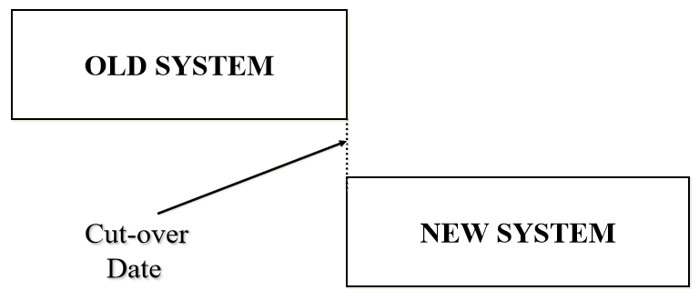

- Most systems pose some problem during the changeover process.
- Hence, this method is generally considered to be risky, because any failure in the new system during the changeover may cause total breakdown of those operations of the organization, which are related to the new and the old system.
- The work cannot progress at all, because the operation of the old system has already been stopped.
- However, this method is preferred in those situations where available manpower and changeover time is less, and the system is not so critical that some problem during the changeover process would lead to a disaster.
Parallel Run
- Both the old and new systems are operated in parallel with the same data for the initial three or four cycles.
- During this overlapping period of complete operation of the two systems, the results produced by the two systems are compared to develop confidence in the new system.
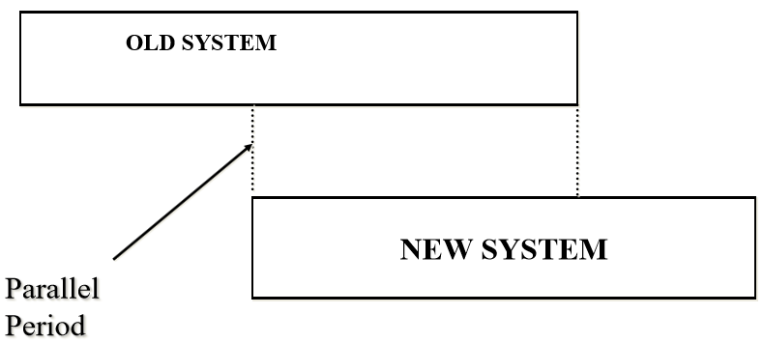
- Some discrepancies may be discovered.
- Often, these are due to inaccuracies in the old system that were not recognized before as inaccuracies.
- Some discrepancies may be due to missing program logic for which no programming was provided, or due to mistakes in the programming itself.
- These must be corrected by further debugging, before the conversion is complete.
- This method is one of the safest ways to deploy a new system, because of the availability of the old system as backup.
- There is no interruption of work if there are problems with the new system, because the old system is still in operation, and the problems found in the new system can be corrected while the old system is still being used.
- However, this method is expensive, because additional manpower is needed during the overlapping period for the operation of two systems in parallel.
- Due to this, the organization is under considerable strain during the period of parallel operation, and organizational breakdowns tend to occur, if the period of parallel operation is long.
- Continuing the two systems for long is a sign of weakness in the new system.
- This method is not preferred in situations where manpower resource is scarce.
- It is also not used in situations where the new system differs to a great extent from the old system in its functions, and its input and output.

Phased Conversion
- The complete changeover to the new system takes place incrementally over a period of time.
- The new system is gradually implemented part by part, and the old system is gradually phased out.
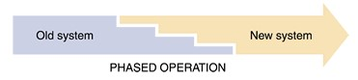

Phased Changeover
- The results produced by each part of the new system are compared against the results of the old system.
- Any discrepancies or errors found are checked and removed.
- Once confidence is developed in a particular part of the new system, that part of the new system is phased in, and the corresponding part (operations) of the old system is phased out.

- This approach is continued for each and every part of the new system.
- Hence, over a period of time, the new system is gradually phased in, while the old system is gradually phased out.
- This method is not as expensive as the parallel run, because the changeover process being gradual can usually be handled with existing manpower.
- There is no danger of interruption of work if there are problems with the new system, since the corresponding part of the old system is still in operation.
- However, it cannot be used in situations where the time period supplied for conversion process is very less, or when the new system is significantly differs from the old system.

Pilot Changeover
The group that uses the new system first is called the pilot site
The old system continues to operate for the entire organization
After the system proves successful at the pilot site, it is implemented in the rest of the organization, usually using the direct cutover method
Pilot changeover is a combination of parallel operation and direct cutover methods
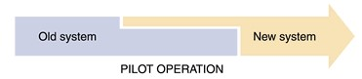

System evaluation
- Once the new system is implemented and put to operation, it is necessary to evaluate the system to verify whether it is meeting its objectives.
- These objectives are clearly stated during its problem analysis and system planning phase.
- The post implementation evaluation is normally carried out by people who have an independent viewpoint, and are not responsible for the development and maintenance of the system.
- The following points are considered when evaluating a system:
  - Performance Evaluation.
  - Cost Analysis.
  - Time Analysis.
  - User Satisfaction.
  - Ease of modification.
  - Failure Rate

Performance Evaluation
- The performance of the new system is evaluated and compared with the performance of the old system.
- Generally, the new system should be at least as efficient as the old one in performance.
- In case of any slack, the reason is analyzed, and if possible, necessary changes are incorporated in the new system to rectify it.

Cost Analysis
- It should be analyzed whether the cost estimate done for the various phases of the project, during the planning phase in the beginning, matches with the actual cost incurred in each phase.
- This knowledge can be used in making correct cost estimates for the new systems, which will be designed in future.

Time Analysis
- It should be analyzed whether the time estimate done during the various phases of the project, during the planning phase in the beginning, matches with the actual time taken in each phase.
- In case of discrepancies, the time analysis will help in finding out reasons.
- This knowledge can be used in making correct time estimates for the new systems, which will be designed in future.

User Satisfaction
- It should be found out whether the users are satisfied with the new system.
- How useful is the system for them?
- How enthusiastic are they about the service they receive?
- Do they receive outputs in time to take necessary action?
- The morale of people using or affected by a system is a good measure of the success of the system.

Ease of Modification
- Sooner or later, all systems need to be modified due to one or more reasons.
- Hence, the ease with which a system can be modified to incorporate the suggested changes is also an important parameter to judge the quality of the system.

Failure Rate
- The quality of a system also depends on its failure rate.
- A system, which frequently fails cannot meet its objectives successfully.
- Hence, it is of poor quality.

